# Introduction

We are a seed stage startup, **CityCollection**, providing a technology platform that enables emerging market collection authorities to efficiently attribute, collect, and direct recyclables. Our platform uses an incentivizing recycling model to gather and understand individual user’s disposal related data, which we will use to educate the said users to reduce, reuse and recycle. We plan to also leverage the insight provided by these data presented via a dashboard to help collectors optimize sorting costs, routes, and drive awareness campaigns.

**Figure 1: Our position in the value chain**

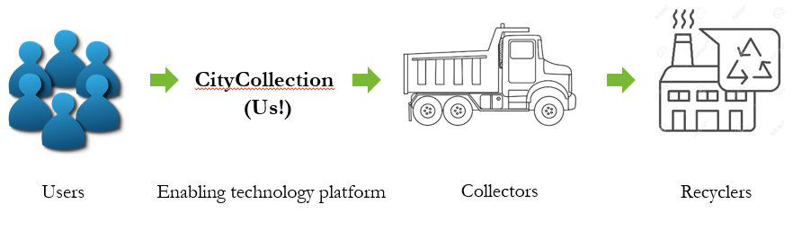

We use an incentivizing and gamifying process to get individuals to throw, segregate, and understand the ‘critical’ recyclable garbage. The core of this is a mobile app supported by an platfrom that we will deploy so that existing disposal and collection infrastructure ecosystems can effectively collect the sorted garbage, and while doing so gather a wealth of data about the disposal patterns of users. Subsequently, our platform also doubles down to educate individuals of reducing, recusing, and recycling their waste. Thus it’s a positive feedback loop; better education leads to better sorting, which leads to more effective usage of the app, which will thus gather and learn further disposal trends. As such we believe this approach is highly scalable.

Once our app has a large enough user base, we will enter Phase II, **CityBin**, is where we will expand to deploy autonomous smartbins to critical areas (i.e. large crowd gathering areas near waterways) that will also integrate into the same redemption platform.

# Sri Lanka’s Pain Points

Sri Lanka is a prime example of disastrous waste management. The extremely inefficient waste disposal systems means that most waste, regardless of their nature, gets accumulated in landfills and dumps. The tragic incident in Meethotamulla in April 2017 where a garbage mound collapsed tragically killing 32 people is a grim reminder that our country desperately needs control of the situation. The Meethotamulla garbage mound was where Colombo’s garbage was being dumped with around 23 million tonnes of it piled on.

Moreover, according to the earthday.org, Sri Lanka is placed as the 5th largest plastic polluter in the world (among China, Indonesia, the Philippines, and Vietnam).

Realising the problem at hand however, progress is being made. There are several waste recycling facilities emerging, both private and public. A few examples of the local recyclers include:

* Viridis - plastics, including PET bottles
* Eco Spindles - PET bottles, HDPE bottles
* Piramal glass - glass manufacturer and recycler)
* E-waste collection - Cleantech
* Neptune Recyclers - paper & board

There are also many fragmented SMEs that separate out reusable items (e.g. large metal objects, E-Waste, glass alcohol bottles, etc.). But the underlying problem still remains - hardly anyone is incentivised to recycle properly, and collections and integration of these systems remain inefficient.

# Existing solutions

A few respectable local solutions have emerged recently. For example, Plasticcycle has placed specially designed bins to support responsible disposal of recyclable plastic. The initiative is supported by two corporate giants in Sri Lanka, Keells and Elephant House. MOreover some start-ups are also exploring the incentivizing model e.g. instant cash at ATM for bottles (like in Germany) and a similar model to ours, paying customers in mobile credits for recycling their waste.

# Business model

**So why are we different?** Because our entire focus is on building an ecosystem that leverages the power of data and education, scales rapidly, and is asset light (we don’t run our logistics and collection, we work with an established partner).

Our primary business, **CityCollection**, has its source of revenue as the recycler’s payment for recyclable items, which will be mainly used to; 1. pay the collector the expenses of the logistics system, and 2. user redemption.

### Collection Model

The business relies on incentivizing customers which will require being able to uniquely ID their waste contribution. We will be providing users with their own unique QR codes and IDs, which will be pasted onto their garbage disposal bags (that are returned on their next scheduling).

Once a pickup is scheduled, our platform will route a truck (given sufficient collection quantity along the path). Where it will deliver the content to the existing sorting arm of the recycler. Here the sorters will use the Validation app (see section XXX) to manually verify if the number entered by the user is the correct amount of recyclables. Once data is mapped to the user, we will provide the redemption when the cash is received from the recycler. Validation by the collector can be done at the user’s premise (e.g. laptops) or on collector’s premise (e.g. lots of PET bottles), via the existing network of manual sorters. The important point to note is that our system **does not require new infrastructure or redesign for any collector**,just a few simple add-ons

**Figure 2: Our business model**

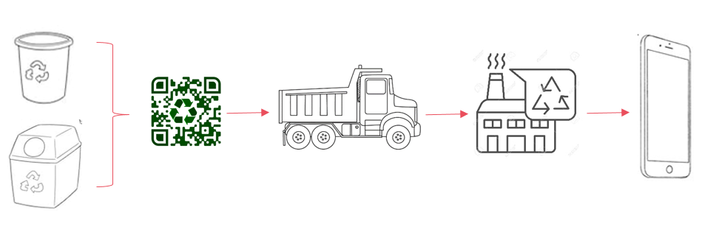

### Financial Model

Increased volume translates to better operating leverage. Our platform aims to build the scheduling service with route optimization (via Google maps) so that the maximum number of items can be collected per km. According to our research and discussions, a typical break even for a collector’s truck is ~$750 (based on 40km roundtrip in Colombo including collection labor; requires a minimum load of 500kg of plastics or ~25,000 PET bottles).

**Figure 3: Financial model**

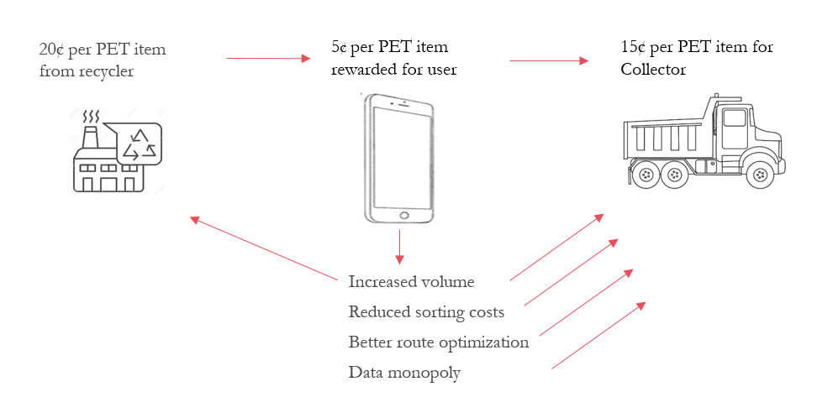

Carefully balancing supply/demand, volume growth, and operating costs is a challenging task. We are working alongside collectors to figure out what the most optimal redemption amount per user is so that we can drive sufficient growth and still cover logistics and add profit.

**Figure 4: Effect of different user redemption rates on collector profits**

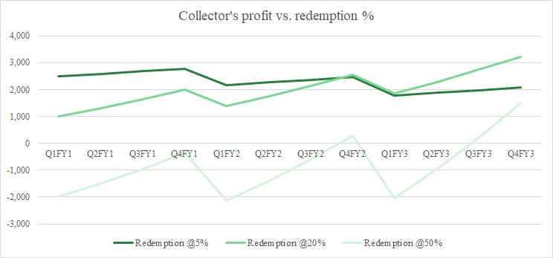

# 

# 

# 

# The Platform

Our current working POC utilizes five main components, two of which are exclusive for CityCollection. The User Mobile is the interface for the user’s mobile device. The App communicates through an API with all the other components of the platform, i.e. the validation app, driver app, and dashboard ^^ .

**Figure 5: Our platform**

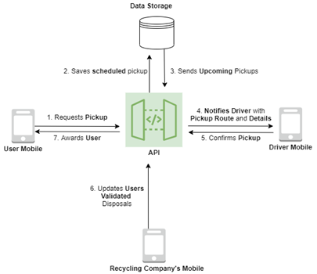

### Mobile App: Interfacing with Users

Our mobile app is the core interface for the users and will have the following functionalities.

>> Booking for pickups

-See upcoming pickups/cancel upcoming pickups

-See nearby CityBins for disposal

-Prize redemption

-News/Advertising

Gamification is a popular method employed by fitness companies to get a user to sustainably support an activity, such as exercise. We are applying the same framework and designing a gamification systems that;

1. Leaderboard for area, with more prizes

2. Collection rewards and patterns

3. Community driven efforts

### Driver App: Helping Navigation

>> Image from ppt

### Validation App: Making Sure You don’t Cheat

>> Image from ppt

### Dashboard: Visualizing the Data

Evaluating the data critically and driving insight is key to our business. To address this, we are building a Dashboard, through which we will be giving meaning to the data we collect by creating visual representations so that the collection authorities could monitor the progress we are making and execute operations in a concise manner and make informed decisions to further drive growth in terms of methodical disposals within communities, which will in turn result in the growth of recyclable waste collection.

One of the key components of the Dashboard will be a heat map, representing the active users we will build through our ecosystem. Through this, recyclable waste collection authorities will be able to visually see where there is user growth and where waste disposal is taking place in a methodical manner or otherwise. With the help of this data gathered, we will be able to further grow our user base exponentially by providing targeted education with the use of news articles, blogs and videos in order to motivate the communities in these areas to get on board with the ecosystem we plan to build (see Mobile App sections).

The dashboard will also display statistical information concerning the growth and progress we are making in terms of recyclable waste collection in order to further understand the patterns of disposals, helping narrow down the contribution made from each location (city), and the gap that we need to meet in terms of the waste that is not making it into the ecosystem and is held redundant on the streets.

### 

### Crowdsourced Data: A Taste of the Data to Come

As an initial approach, we collected recyclable waste disposal data by providing people in our local community with an online form, in which they were required to fill a few fields related to the recyclable waste they were throwing away on a daily basis. Below is a screenshot of the form that we asked people to fill before throwing away their waste. We also discovered a psychological side effect of our survey; participants became acutely aware of their trash footprint, every time they took a picture/entered their disposal items into the app. In several cases, **it caused them to rethink buying unrecyclable** products. This is an example of how our **ecosystem reinforces the ‘Reduce’ principle** of the waste control pyramid.

The images below illustrate the initiative taken to bring life to our POC. This is only an initial approach we took in order to gather as much data as possible to better understand how we would gather such related data with the help of our end to end platform.

**Figure X: Data Collection Form**

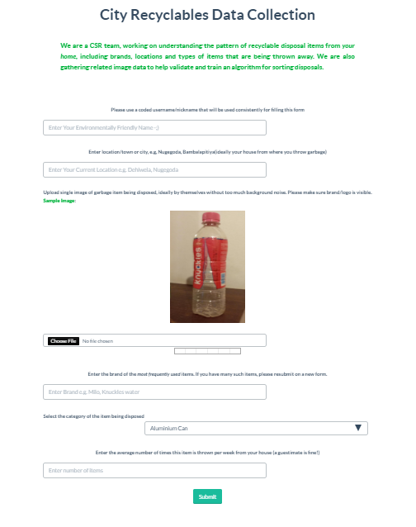

Using this approach we were able to collect data concerning the location, types, and brands. Below is a sample of the data we collected across 100 participants in the colombo district.

>> Remove actual names, Replace with ID

**Figure X: Data Collected from Users**

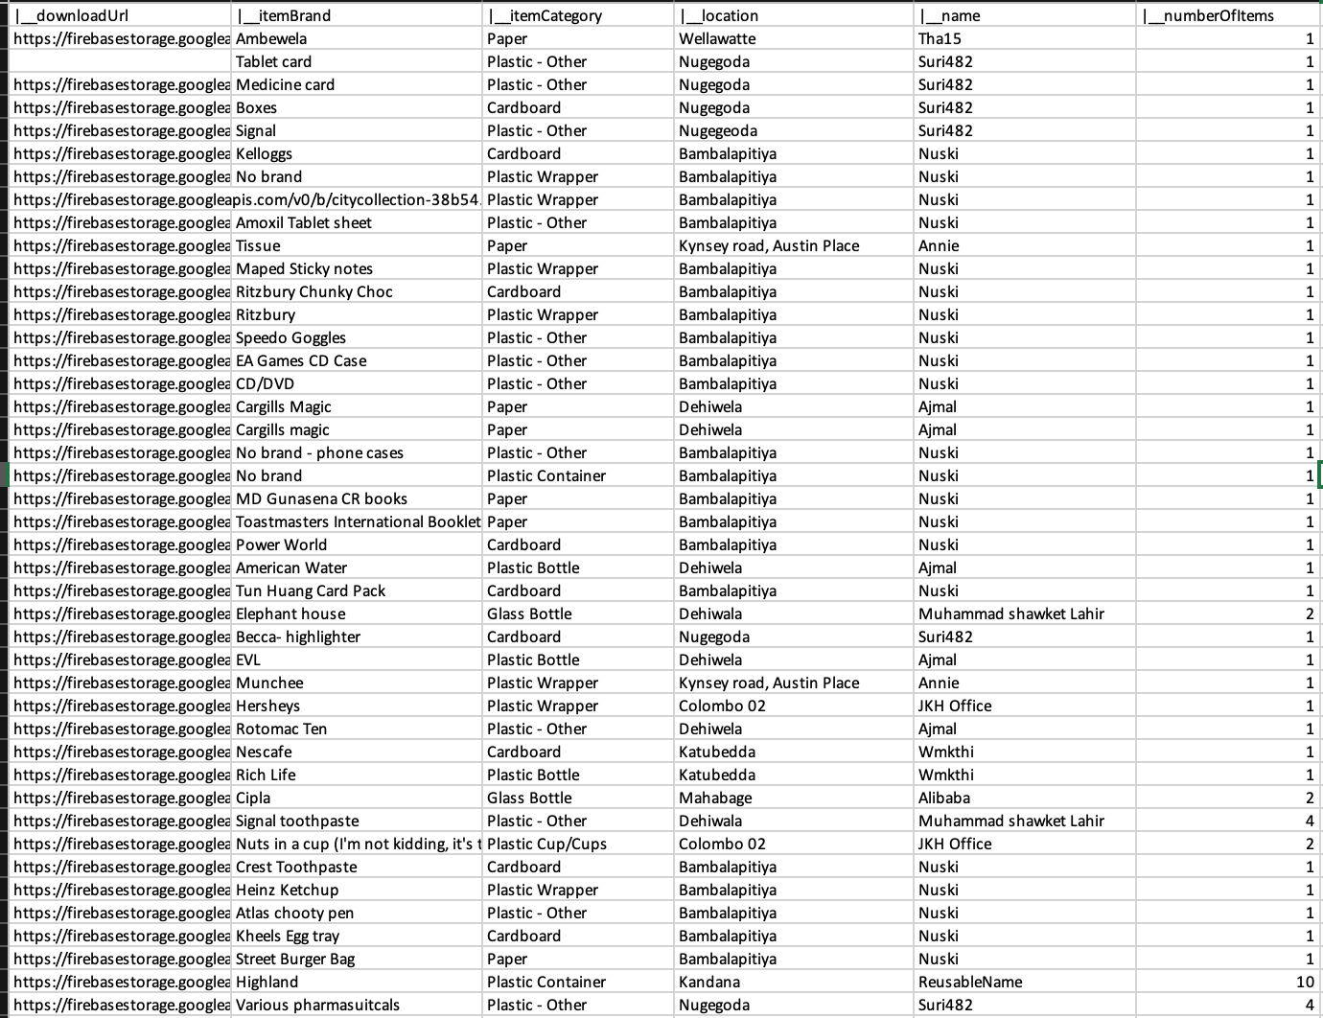

As shown in the screenshots above, this form is an initial idea on the type of data we will be collecting from the users on our platform. Subsequently, the below is an example of a heat map based on the crowd sourced data we gathered.

**Figure X: Heap Map Representing the Users Actively Recycling in Specific Areas**

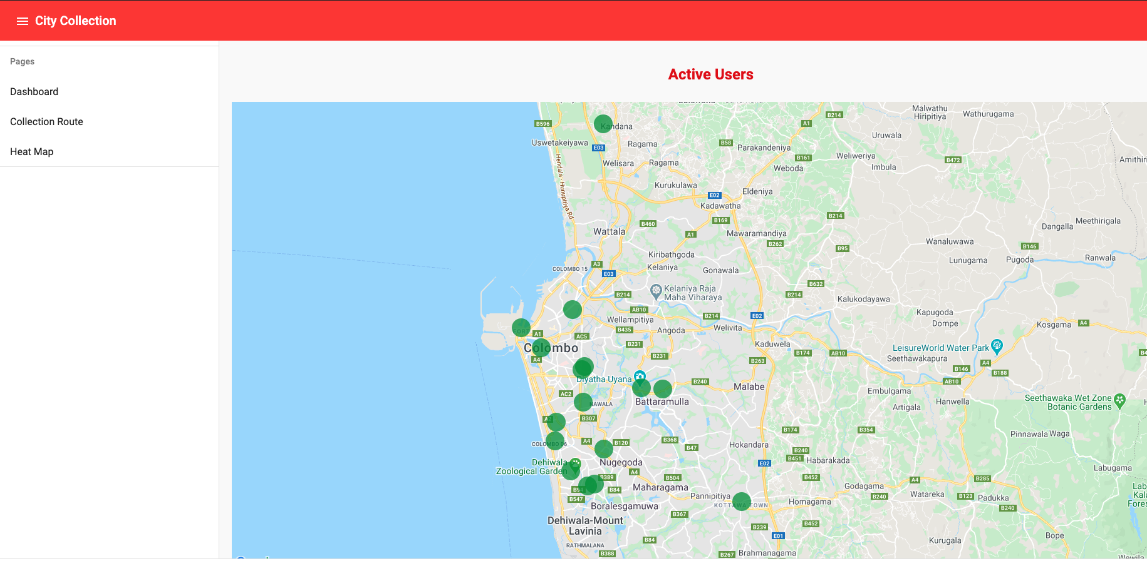

### CityBin: Recycling Everywhere

CityBin is phase II of the platform where we leverage the collected garbage image data from CityCollection to deploy physical ‘ultra’ smart garbage bins that allows users to dispose of garbage items in them and rewards them for the trash with points. A CityBin is an “auto-segregating” smart garbage bin that can be placed anywhere (sidewalks, malls, cafeterias, schools), these bins reward you with points for using them to recycle . The bins will be placed in areas where large crowds gather, especially near waterways (after analyzing data we gathered from community level user disposal trends).

**Figure Y: SOLIDWORKS preliminary skeleton of CityBin**

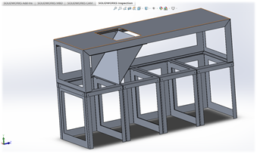

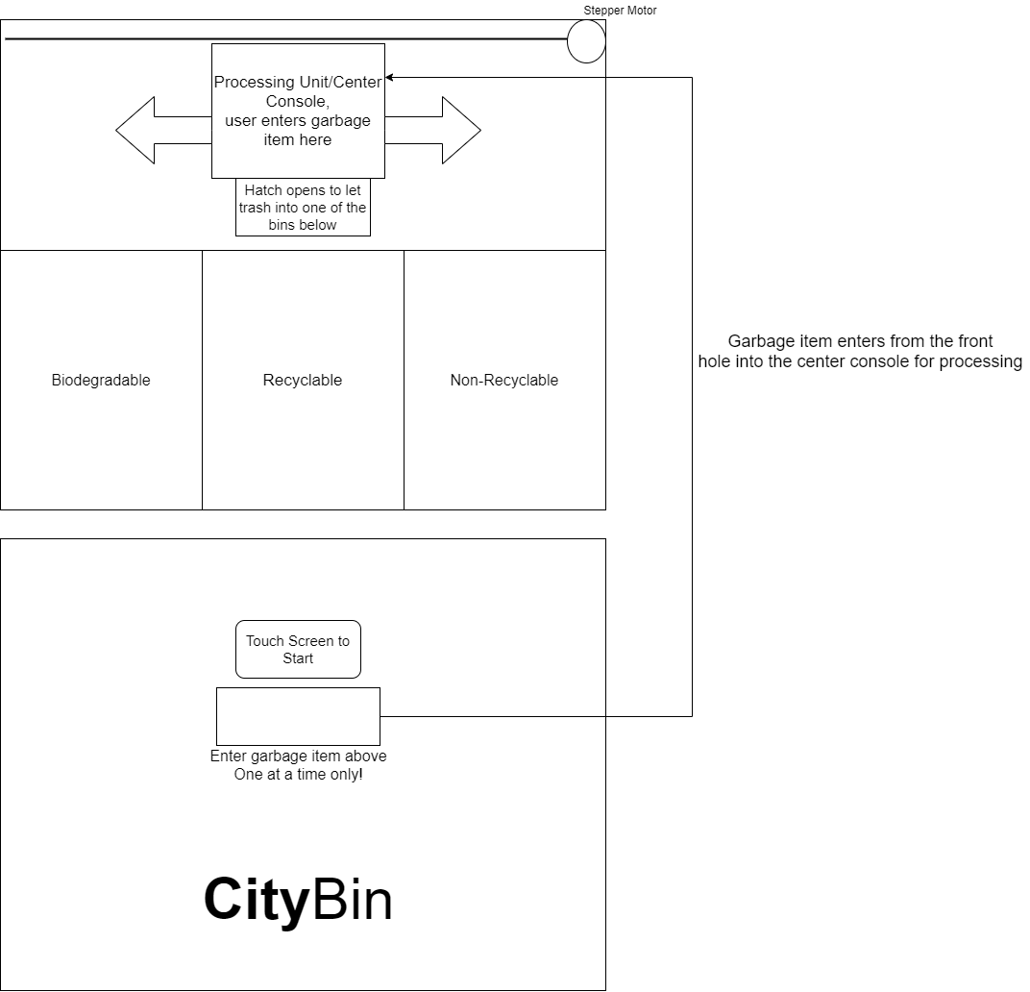

**Figure X: CityBin Processes**

1. User enters a garbage item into CityBin via the front hole
2. It goes into the processing unit where the android tablet takes a picture of the item.
3. The tablet has a local image classification model capable of classifying the garbage item.
4. Once it figures out the item, the processing unit moves left or right until it is above the proper bin.
5. The hatch opens allowing the garbage item to fall into the proper bin.
6. The bin updates the platform on the disposal and the platform awards the user a certain number of points based on the disposed garbage item.

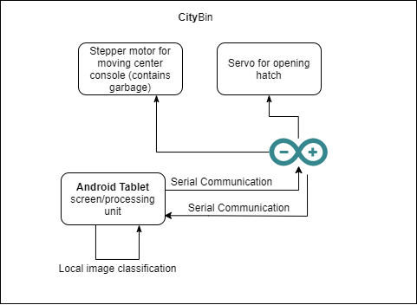

**Figure X: Inner Workings of CityBin**

The current version of CityBin consists of an Android tablet that acts as an interface for the user and the primary processing unit of the bin. It’s camera is used to take the image of the garbage item as well. It communicates with an arduino device via serial communication. The arduino device acts as a dummy device only acting on commands from the android tablet, the device is constantly waiting for a command from the tablet. Once a command is sent, the arduino performs the command, these commands include moving the bin above the non-recyclable items bin and opening the hatch, etc.

*Local image classification is done on the android tablet itself using Tensorflow Lite, see next section.

### Image Recognition: Reinforcing Identification and Reinventing Sorting

Before we dive in, **image recognition is not yet a core part of our business model for CityCollection.** However, it will be the stepping stone for gathering data which we will use for 1. CityBin, 2. exploring new industrial sorting mechanisms, and 3. tagging conditions of recyclables to gauge reusability (hence the second section of waste management pyramid).

**CityCollection - Object detection and classification:**

In CityCollection, we will incentivize users (subsidised through our core business) to take pictures of high frequency trash and label them with brand and type information. This will form a labelled dataset for performing supervised learning (similar in business model to Amazon’s Mechanical Turk).

Using the labelled images from our crowdsourced data (see Crowdsourced Data) we pre-trained YOLOv3 to see how effective such a system would be. We are currently in the early stages of the training, yet we are seeing convincing performance in our model.

Our latest custom YoloV3 is capable of identifying 4 brands (trained purely through the crowdsourced image data; to be extended to >500 brands as data comes in) to achieve mAP of 70% @IOU of 50%. Our aim is to train the model to be capable of high mAP’s at high IOUs, given the density of disposed items that may require detection at a sorting conveyor belt in a potential industrial use case. We used a variety of image augmentation tools, including changing hue, brightness, scaling, and background augmentation, to enable us to achieve this performance, even with a small dataset.

**Figure X: Detections of out-of-sample items**

#### 

Currently, the algorithm is very effective in identifying the item when its brand is clearly visible, however it becomes less confident (and thus doesn’t recognise) when the brand/logo is unclear, stretched, distorted, etc. We are currently in the process of experimenting with a variety of blurring and shearing augmentations to overcome this issue.

#### 

**CityBin - Image classification:**

Our other model is a mobile friendly device and works by classifying singular items at a time. It works by identifying the broad categories of objects in an enclosed trap (i.e. CItyBins disposal box). We have used the Mobilenet model and trained the last 3 layers of the model through our dataset. The challenges are much more controlled in this case given that we are operating in a predefined environment. Albeit, the training data are also required to be set in this background, thus we are using a variety of background augmentation tools to build a suitable dataset.

**Figure X: PET bottles in enclosure**

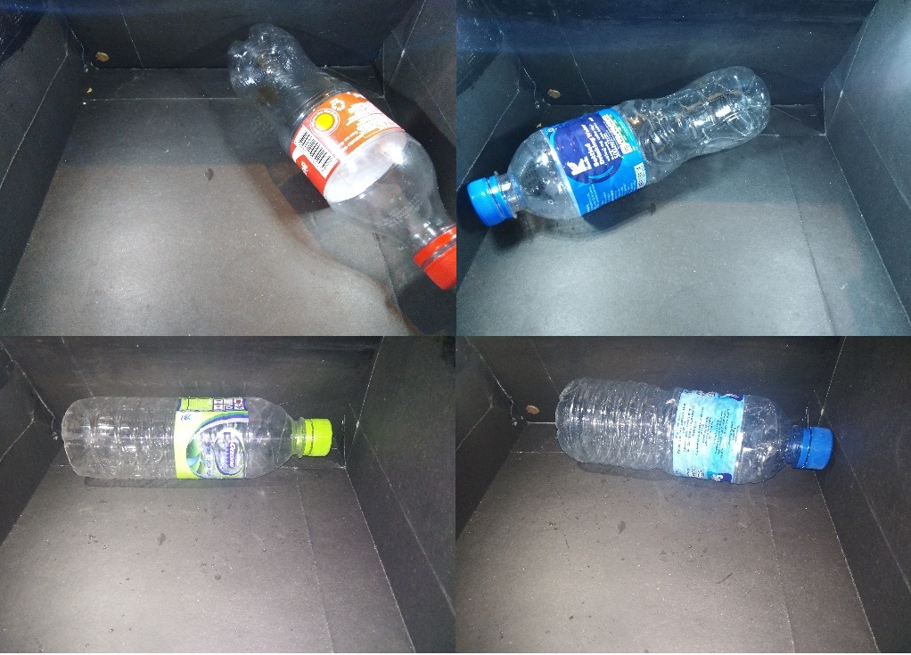

The model is capable of identifying PET bottles with >90% accuracy due to the constrained nature of the environment. Even outside, the model is capable of identifying different types of items.

**Figure X: Example classifications**

>> Image of real time algo on android

# Challenges we Address

To understand how our solution neatly addresses every problem in the challenge, either directly or indirectly, we have organised a Q&A session below.

## **Challenge 1 -** Improved Visibility of Plastic Waste Generation and Material Flows

* Southeast Asia’s existing systems are complex, often fragmented, and heavily reliant on the informal economy.
* Lack of visibility and transparency on plastic waste generation patterns as well as plastic waste material flows

Questions & Answers

1. How to better track and understand where plastic waste comes from and where it goes?

* CityCollection allows for end-end user trash tracking and attribution
* Dashboard tracks location, frequency, type, and even brand data via the image recognition portion of the app. The data is used to identify individual and community wise user patterns and behaviors to better focus collection efforts

1. Better understand waste generation based on its quality (type, cleanliness, etc) and source (urban/rural, commercial/household, community-level/country-level, etc)?

* Image recognition to help identify the cleanliness and reusability
* CityBin improves on the data collection procedure by going directly to the source of outdoor waste disposal (e.g. shopping malls, events)

1. Predict the consumer attitudes and behaviors to identify potential channels of influence on plastics?

* Dashboard summarizes all of the relevant data to help identify individual and community wise user patterns. News’ section which displays weekly updates about plastic and waste related issues to initiate public education of responsible disposal of garbage

## **Challenge 2** - Optimization of Circular Supply Chains for Plastics

* Collected-for-recycling rate of PET just ~26%, yet they import a large quantity
* Insufficient pricing of post-consumer materials/lack of visibility of post-consumer materials pricing for informal sector waste collection
* Lack of value creation mechanisms in the local supply chains
* Poor and short-term plastic waste collection efforts resulting in insufficient supply of quality, clean plastic feedstock
* Lack of new delivery models to eradicate usage of plastics

Questions & Answers

1. How might we incentivize responsible for plastic use and waste management?

* Success rate of recycling is a direct function of the value of our incentive scheme. Our surveys across the regions of Colombo indicate that a range of LKR 150-400 per month is enough to get users to actively engage in collecting, and sorting their recyclable waste

1. How might we enhance the visibility, connectivity, and efficiency of informal sector waste collectors and aggregators?

* ‘News’ tab drives education and allows for community and collector to run awareness campaigns

1. How might we improve the visibility of pricing?

* Building backend ‘marketplace’ to support integration of a network of recyclers and collectors

1. How might we better track and improve value generation across the supply chain?

* Image, location, time series disposal, brand, and type data is gathered to help the us/collector understand source, generation, and evaluate collection strategy and integrate fragmented value chain. Moeovevr, our state-of-the art image recognition and object detection algorithms will be trained on the wealth of image data to perform multilayered, segregation into increasingly more specific classes (e.g. reusable vs. reusable yoghourt cups packets). This enables more efficient industrial scale sorting reducing the requirement for manual labor (see object detection algorithm)

## **Challenge 3** - Identification & Prevention of Plastic Waste Leakage

* 80% of ocean plastics come from land-based sources
* Assessment of contributions to ocean pollution from inland populations through riverine systems has been less frequent.
* Explore advanced data solutions to better map, monitor, understand, and forecast plastic leakage into the environment

Questions & Answers

1. How might we map and monitor plastic leakage entering waterways?

* This is an extension of the dashboard app in which we will layer the water bodies, including rivers and lakes nearest to the heat map for high activity locations.
* This allows for targeted collection and education in these critical zones.

1. How might we better understand and address how plastic leakage relates to external factors (landfill location, waste storage, socioeconomic factors, etc)?

* The sample user volume and location data is used to predict the fill rate of local landfills. It can even be used to predict collection capacities and requirements ahead of large beach events etc, and deploy resources effectively, once the representative user base has grown.

# Our Team